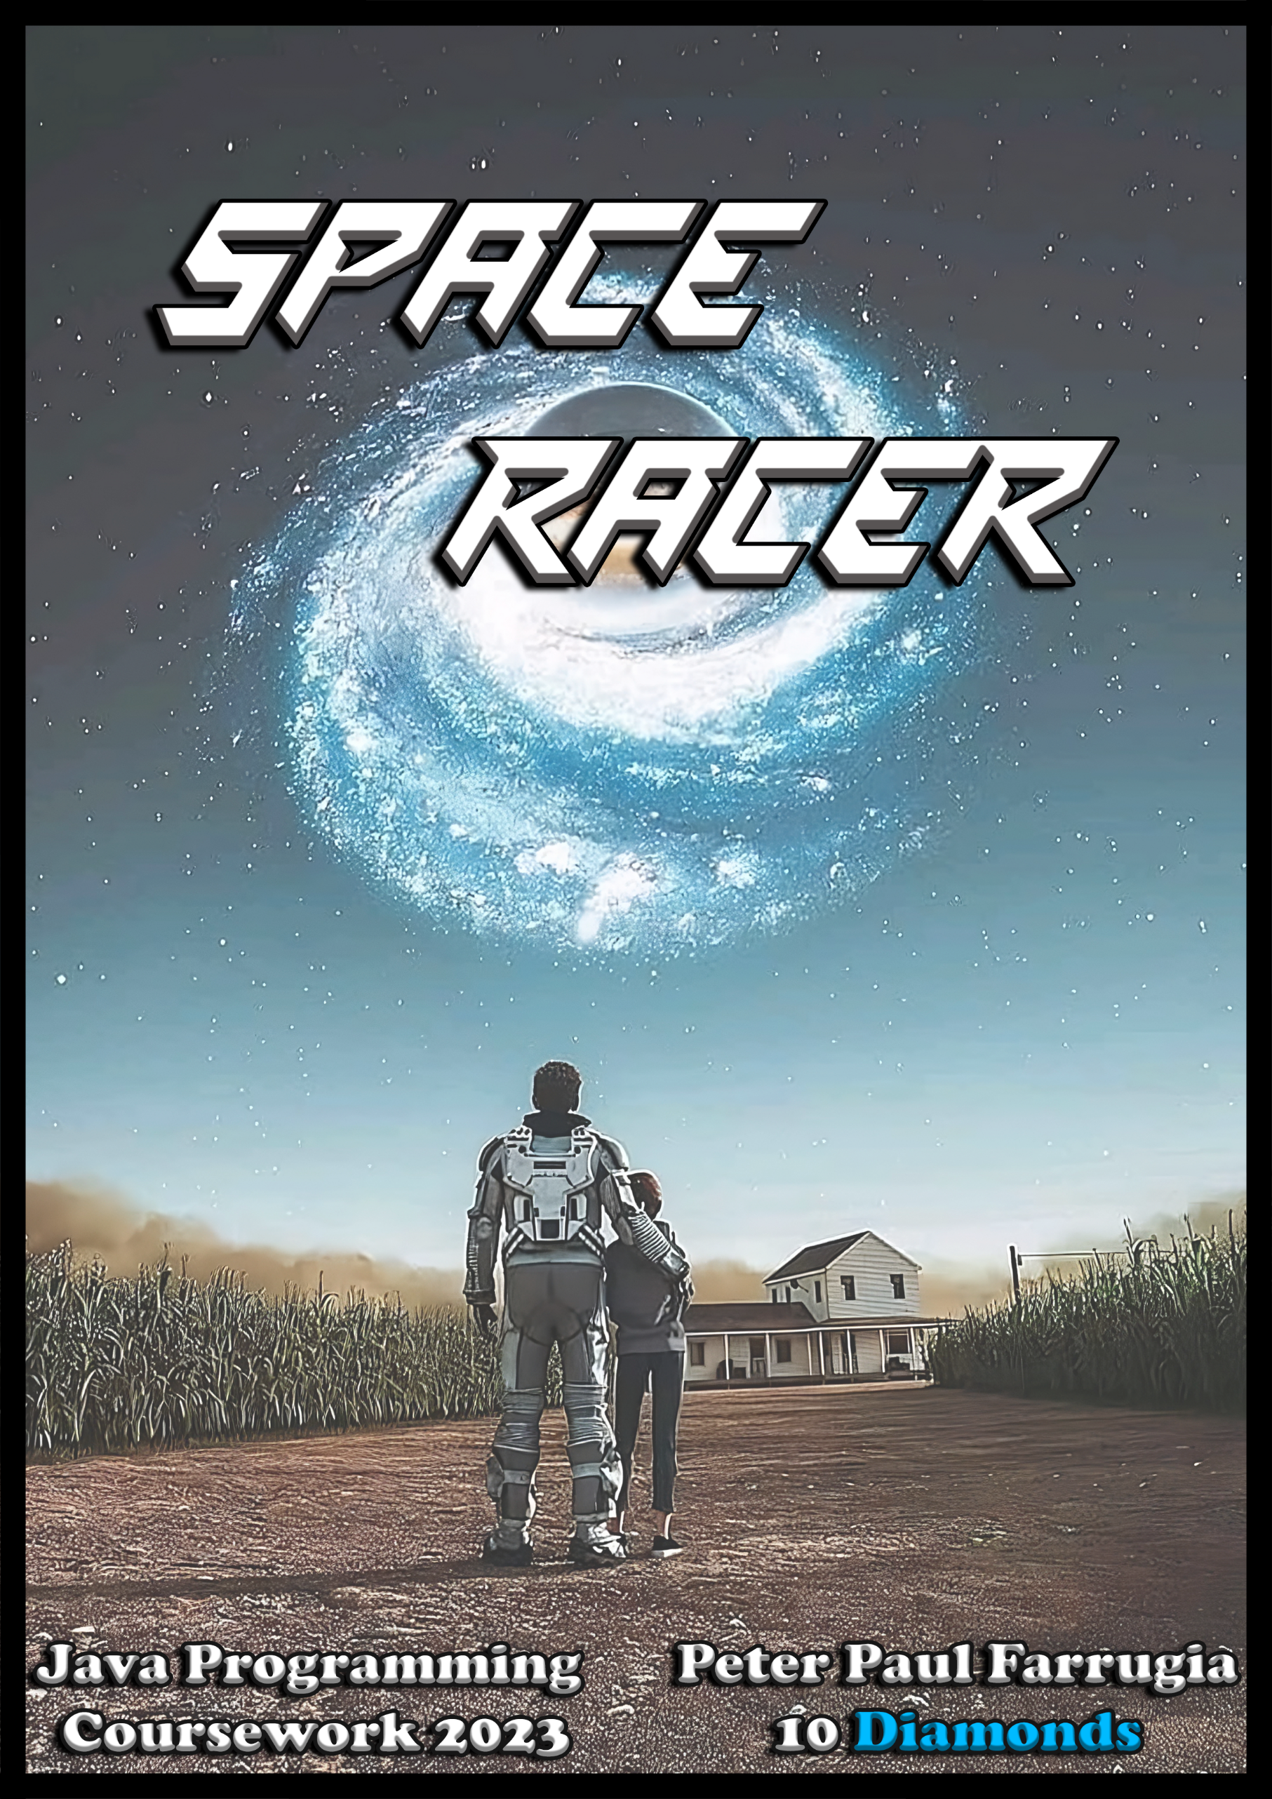

Table of Contents

**INTRODUCTION**

What is Programming?1

Program used in this Project2

**PROBLEM**

Problem Definition3

Problem Solution – Game Description4

Flowchart - Main Menu5

Flowchart - Game Method6

Flowchart - Switch Method9

**LISTING OF PROGRAM**

Screenshots of Program Code14

**Coursework Papers**

Coursework – Requirements24

Coursework – Marking Sheet25

**Introduction**

**What is Programming?**

Programming is the process of performing a particular computation, usually by designing and building an executable computer program. Programming involves tasks such as analysis, generating algorithms, algorithms' accuracy, etc.

Programming can be written using varies programming languages. Some popular programming languages are:

* Java
* Javascript
* Python
* PHP
* C#
* C
* C++
* SQL
* HTML
* CSS

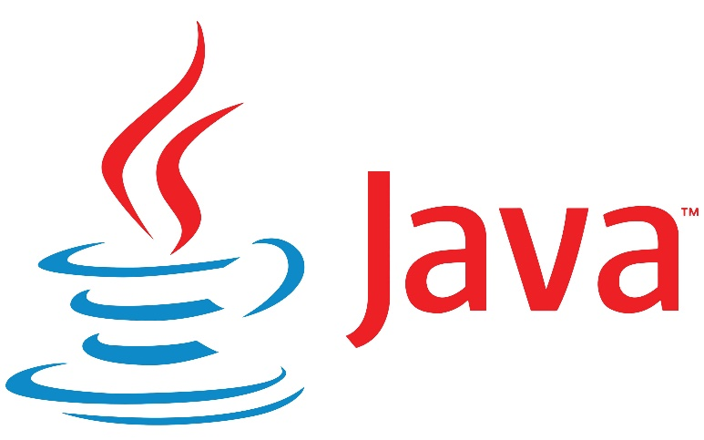

**Program used in this Project**

The program used to code this project was Visual Studio Code (VS Code). VS Code is an integrated development environment from Microsoft. It is used to develop computer programs including websites, web apps, web services and mobile apps. It can support all the popular programming languages including Python and Java.



**Problem**

**Problem Definition**

You are required to choose Problem 1 or Problem 2:

**Problem 1:**

Class Marks - You need to program an application to handle basic class mark management procedures. These could possibly include all or some of the following:

* Entry of names and marks in an array
* Basic data processing:
  + Generation of statistics: average mark, lowest mark, highest mark, marks above average, marks below average.
  + Generation and display of grades.
  + Generation of simple histogram showing grade distribution.
* Output of data as requested by the user.

OR

**Problem 2:**

Game – Example: Space Racer

A spaceship captain decides to fly to Saturn and goes all the way to Neptune, with 40 asteroids in-between. The captain must roll a dice and move forward several asteroids depending on the result of the die. The captain should keep doing this until the spaceship reaches the 40th asteroid which is the one next to Neptune. However, during the journey there are some surprises – certain asteroids contain gold deposits and others have nearby wormholes.

**Chosen Problem: Problem 2**

**Problem Solution – Game Description**

The program (game) that I developed is a space game about a space traveler who has a mission. His mission is to make it and land on Europa (Jupiter’s Moon). But he first must travel from Earth to Mars and from there he has to travel across 100 asteroids, meanwhile he has several random chances of being teleported by wormholes to the Sun, an unknown area of the universe, or get hit by a meteoroid. If so, he’ll have to get back to Earth to repair his ship. At the end of the day his mission is to make it to Europa in one piece!

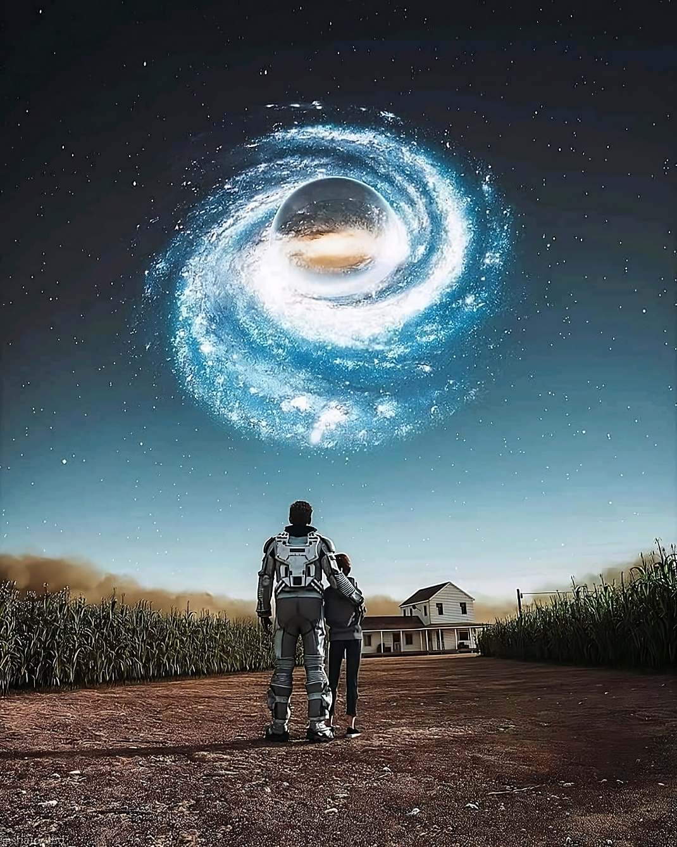

**Flowchart – Main Menu**

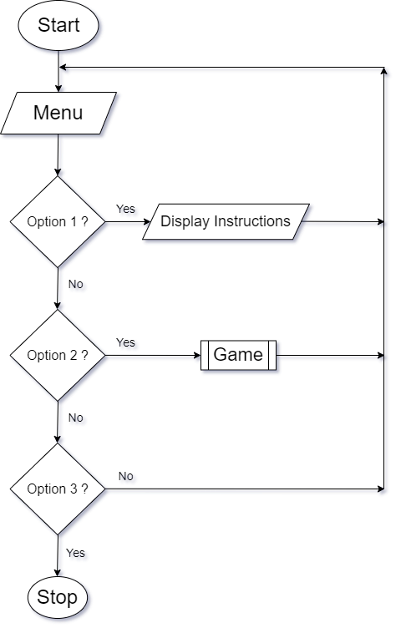

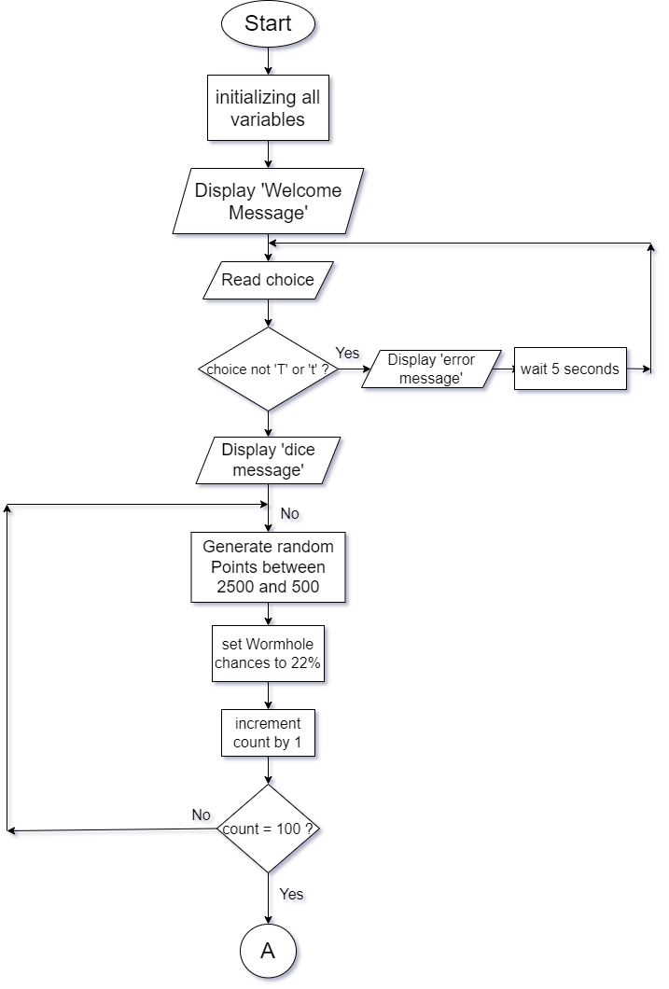**Flowchart – Game Method**

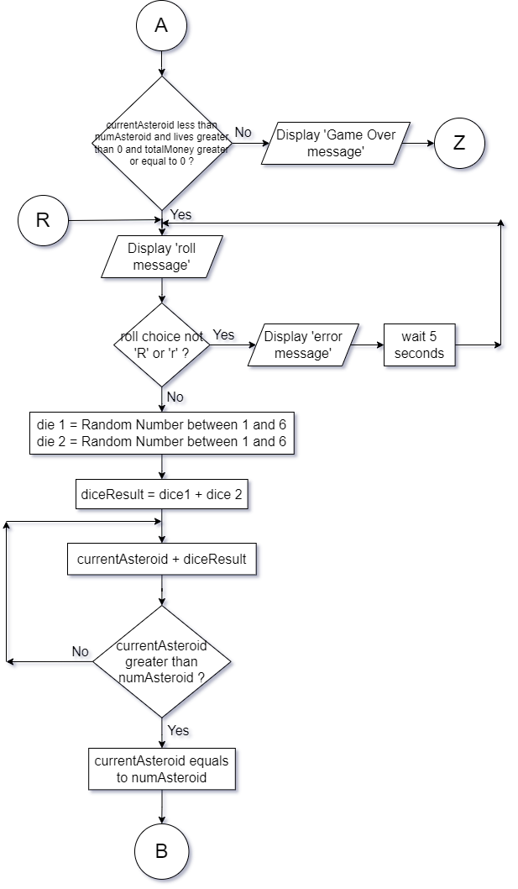

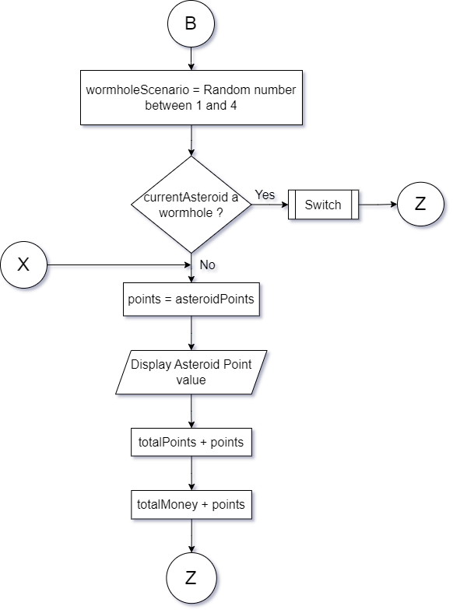

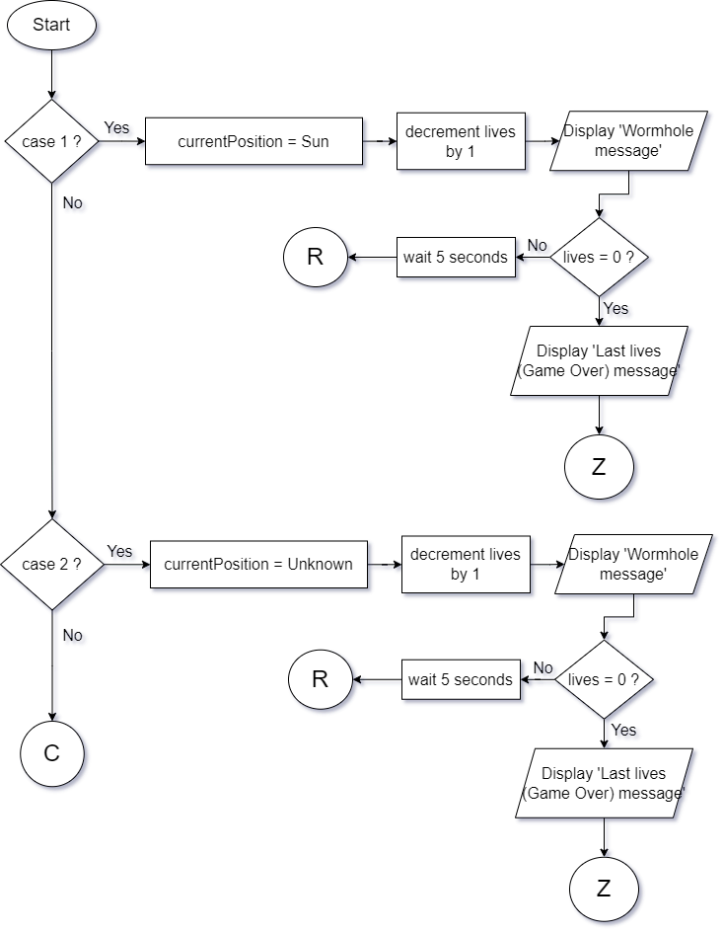**Flowchart – Switch Method**

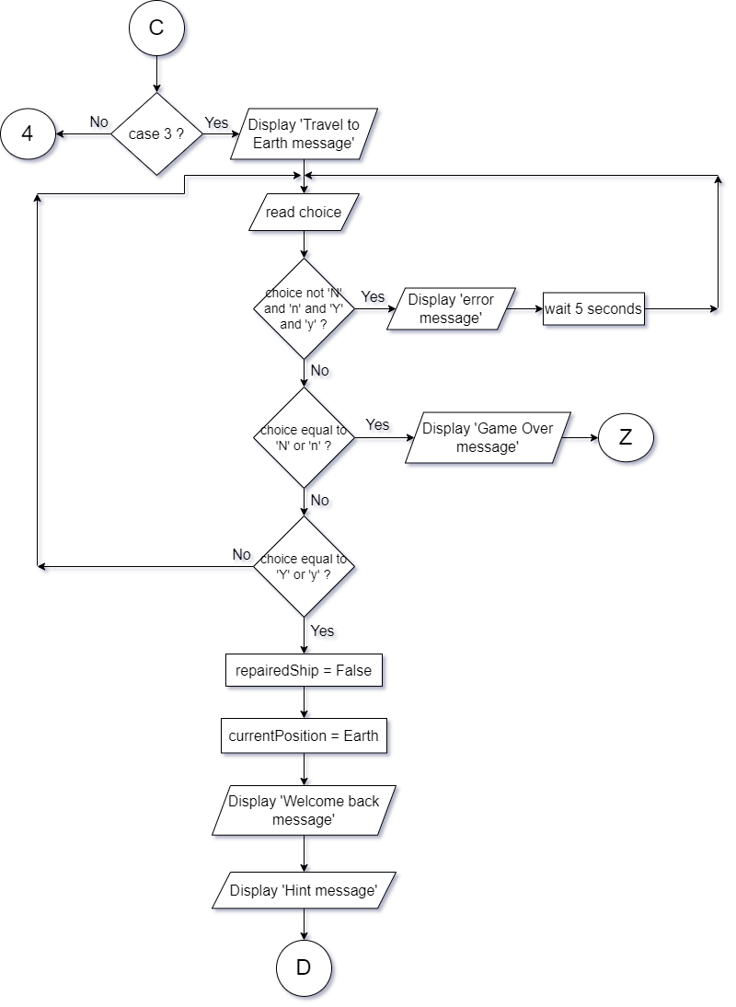

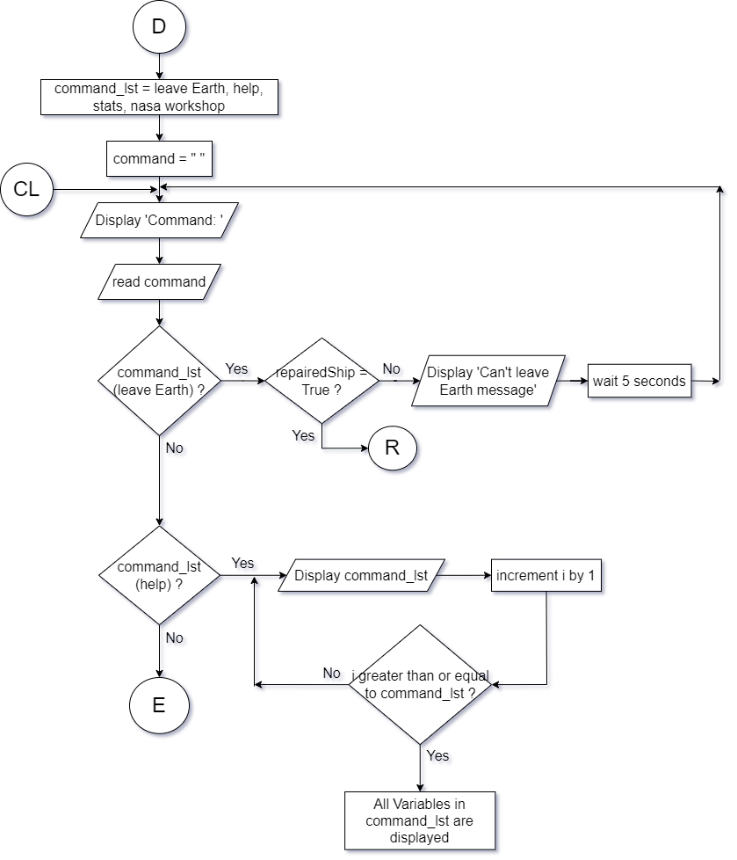

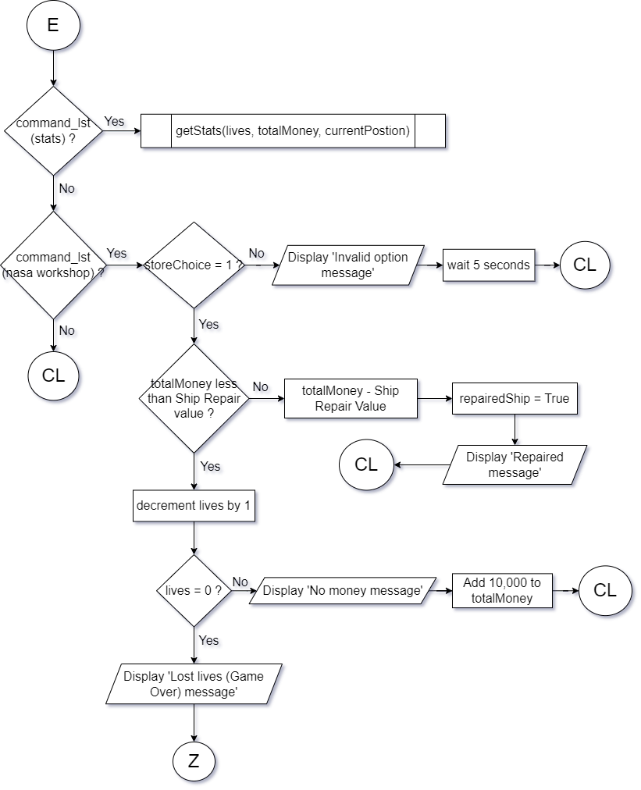

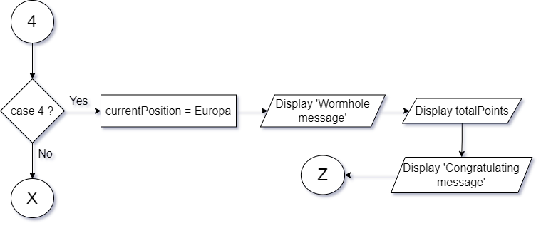

**Listing of Program**

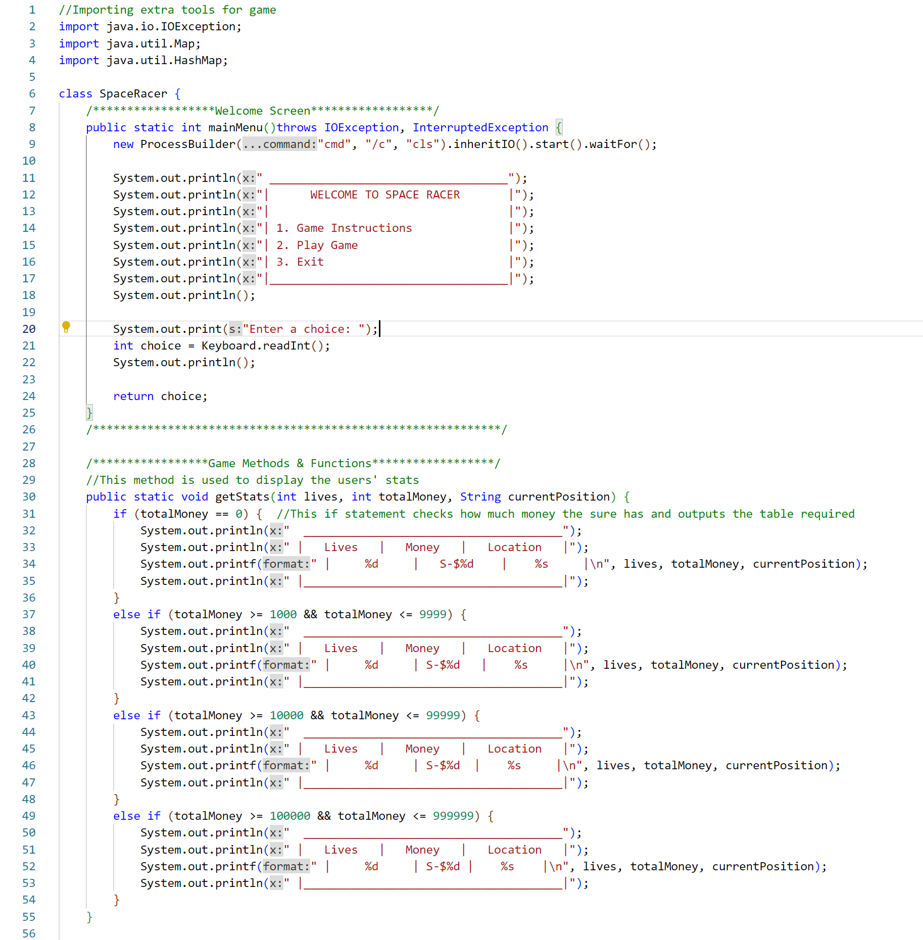

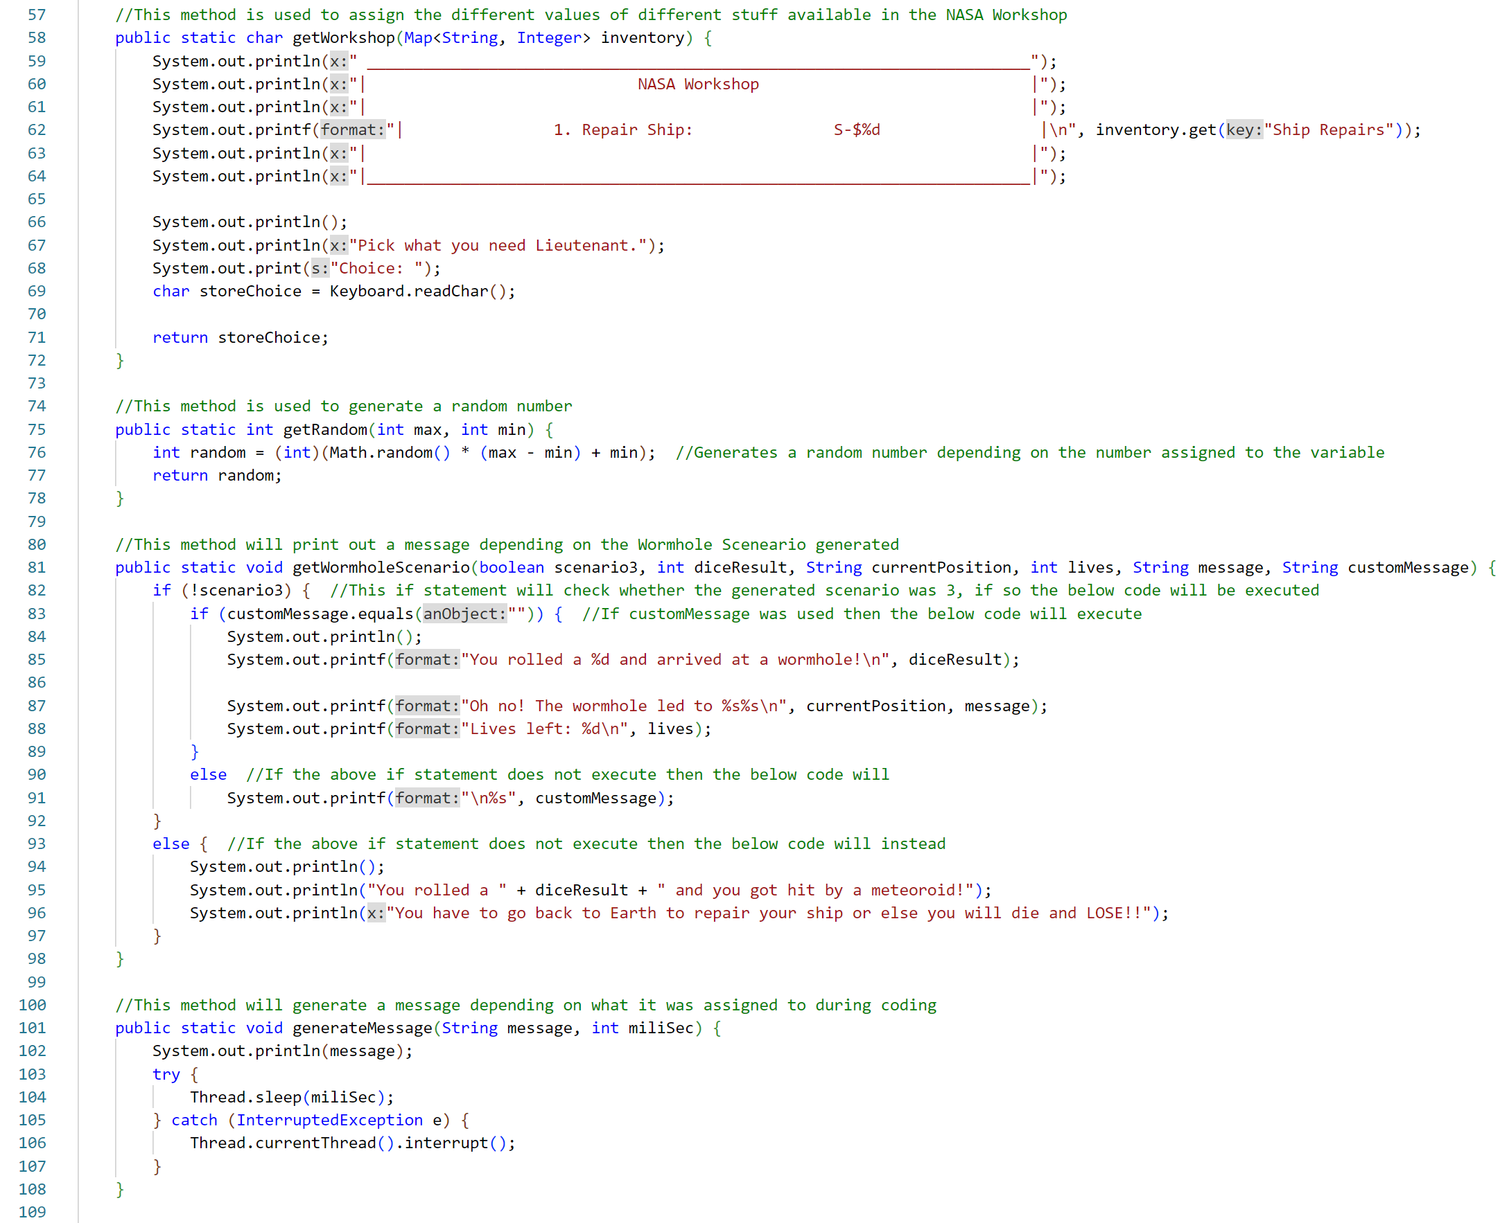

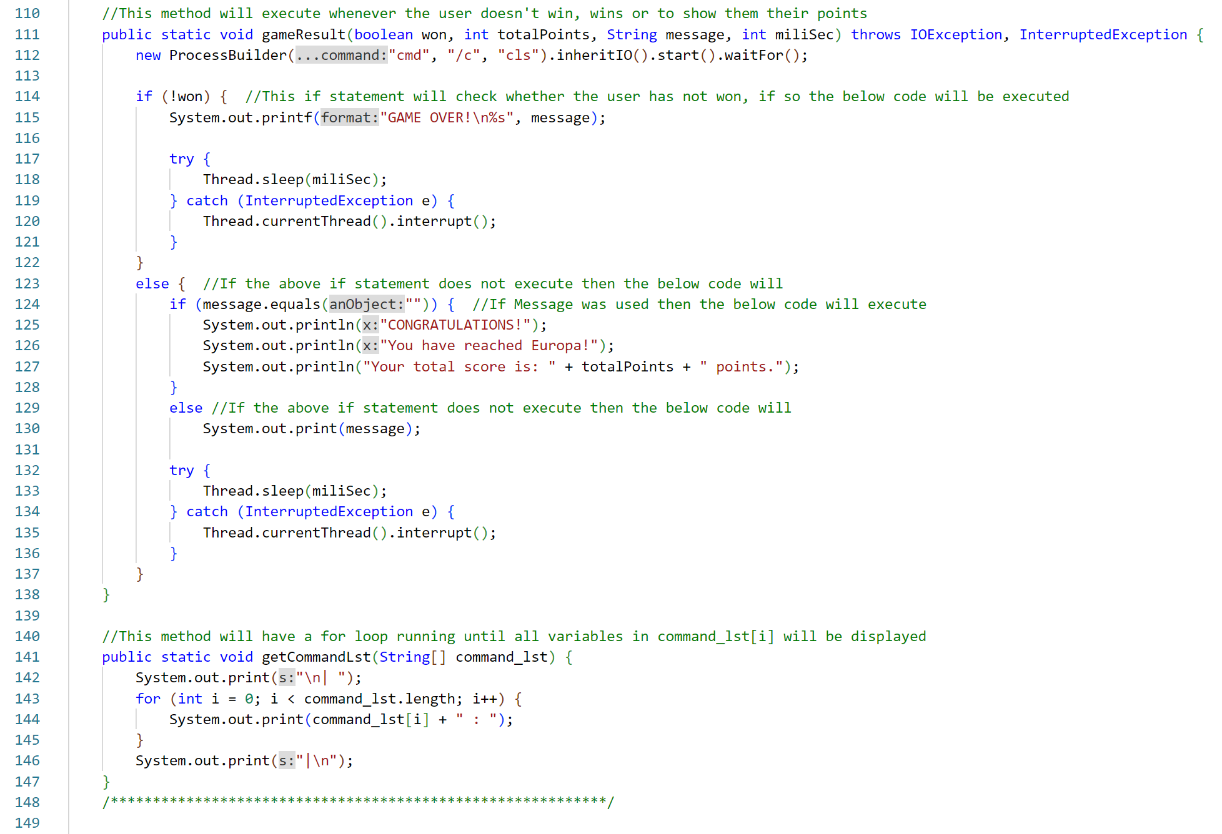

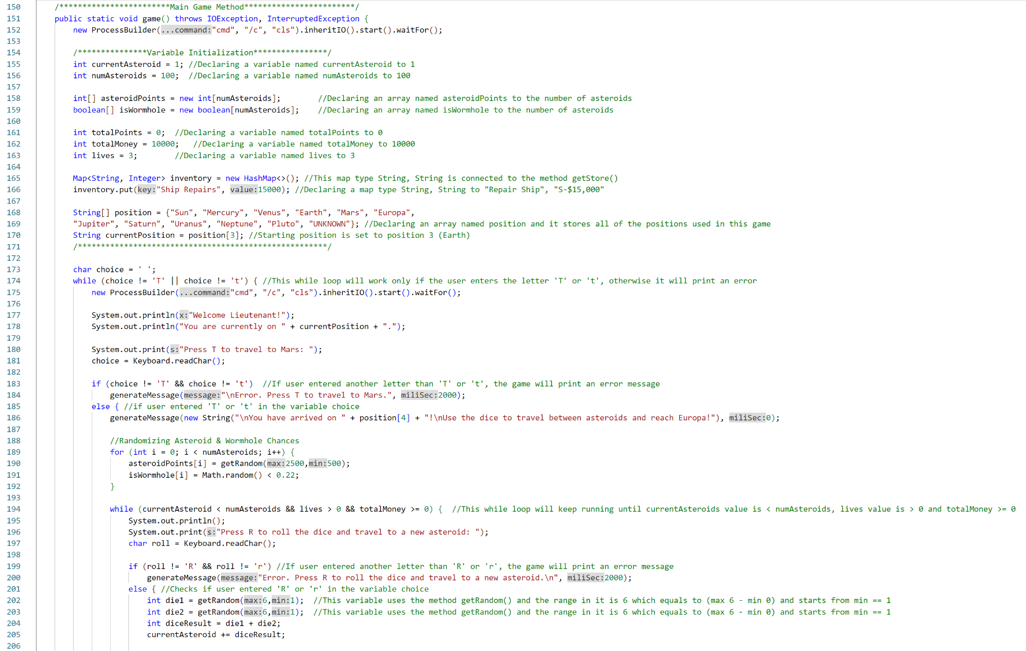

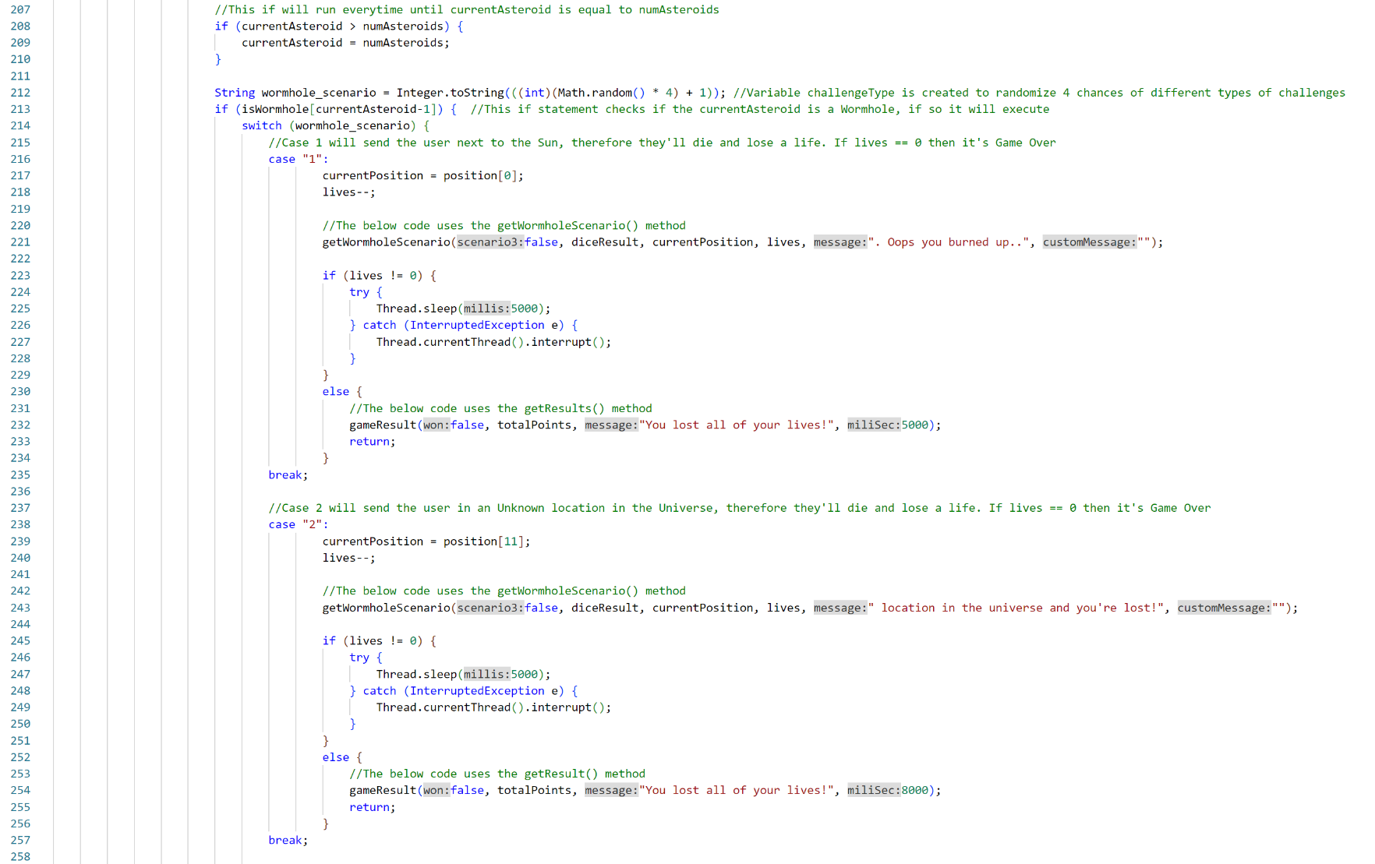

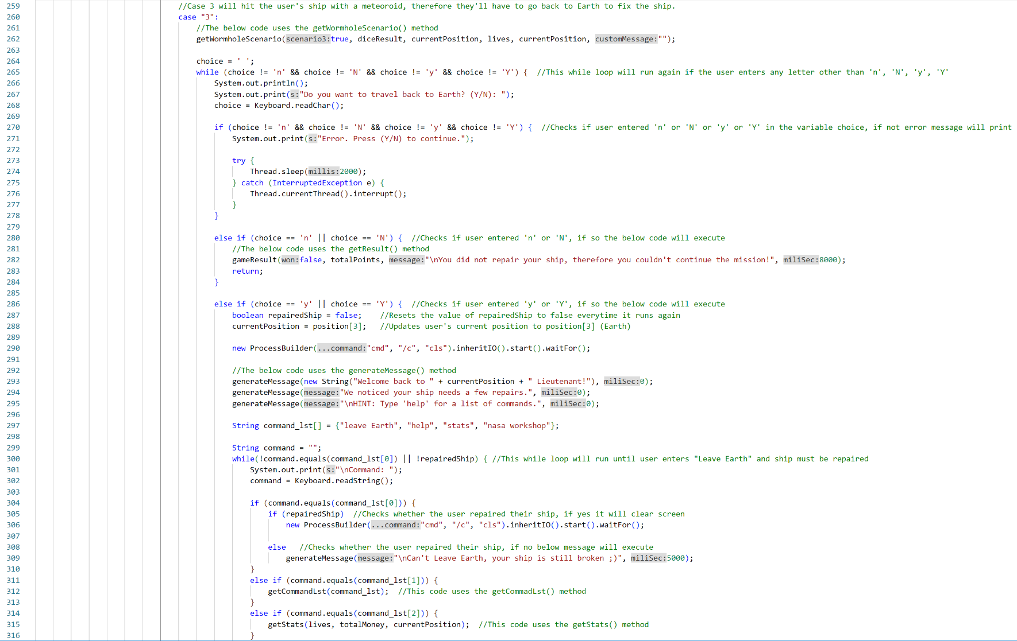

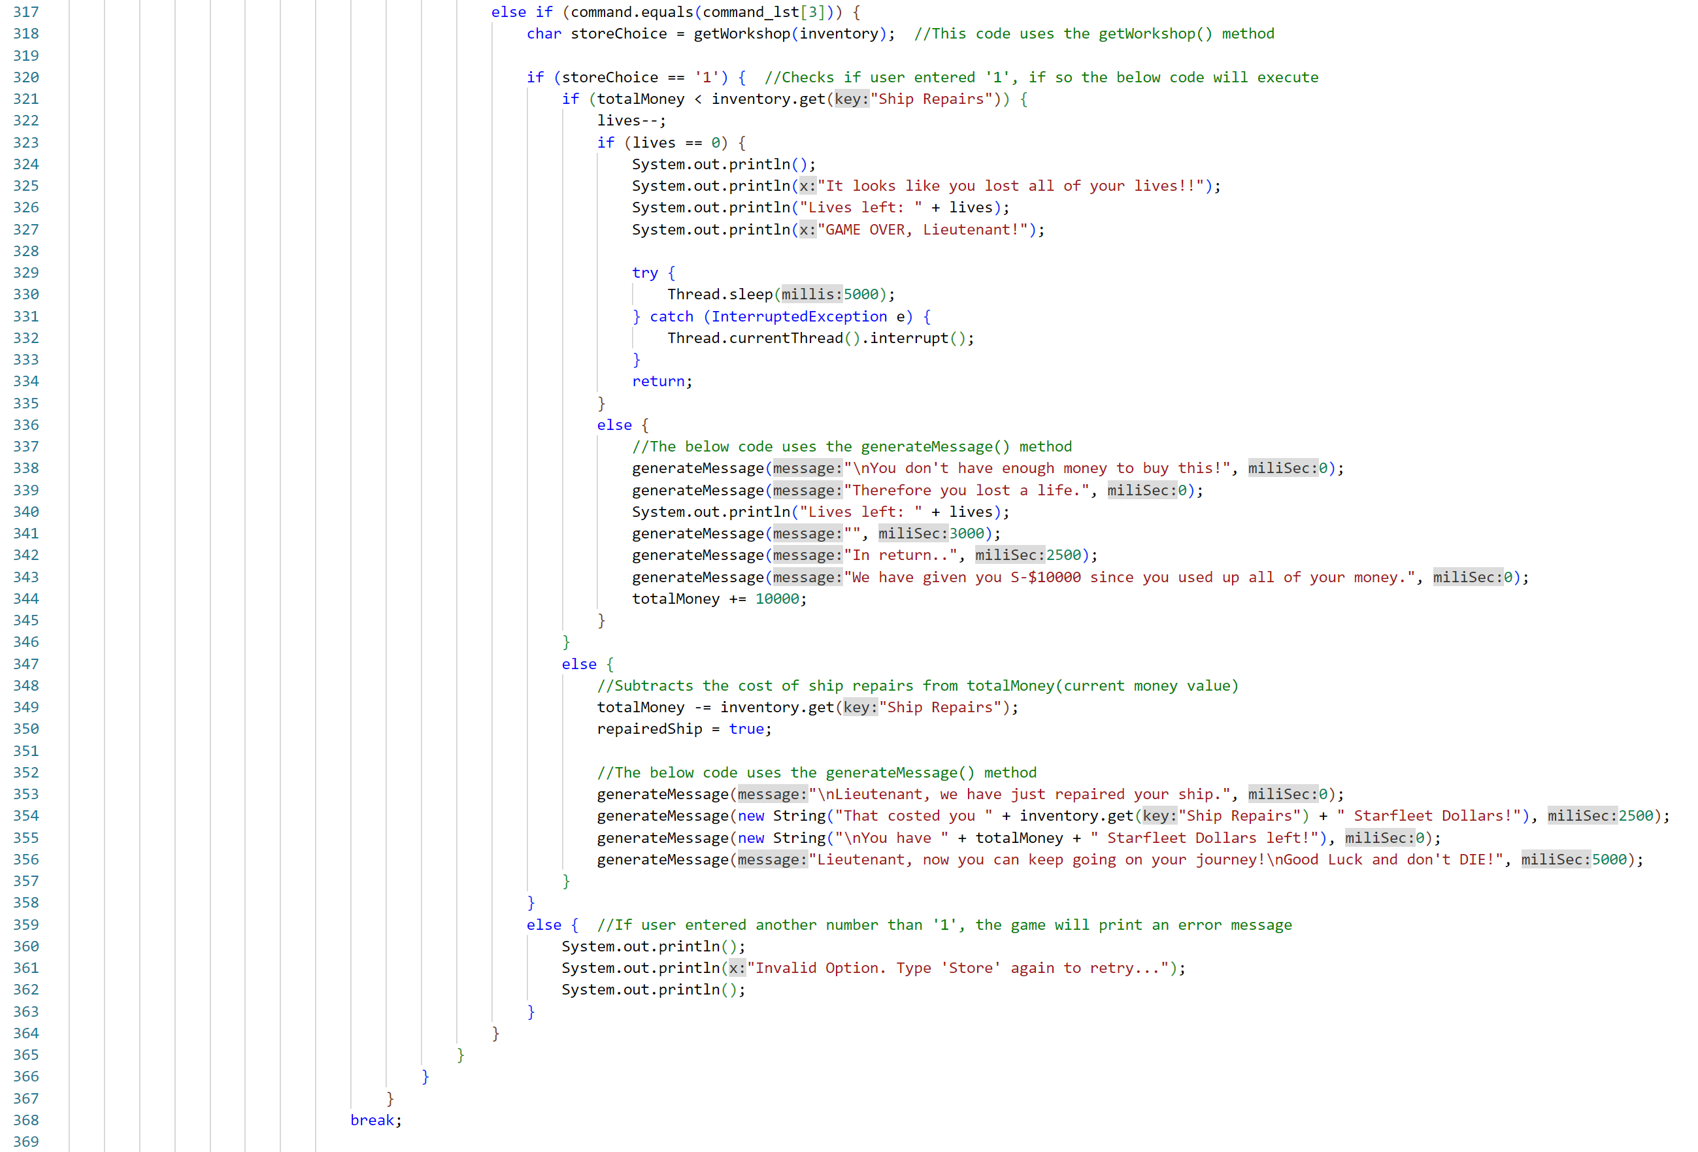

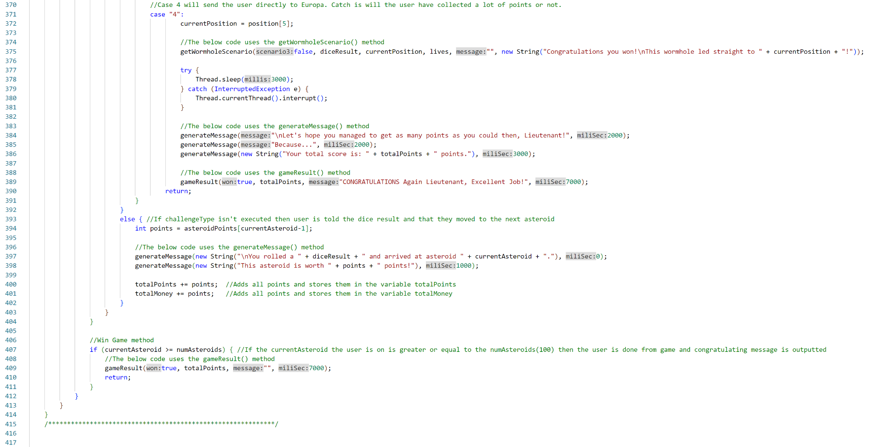

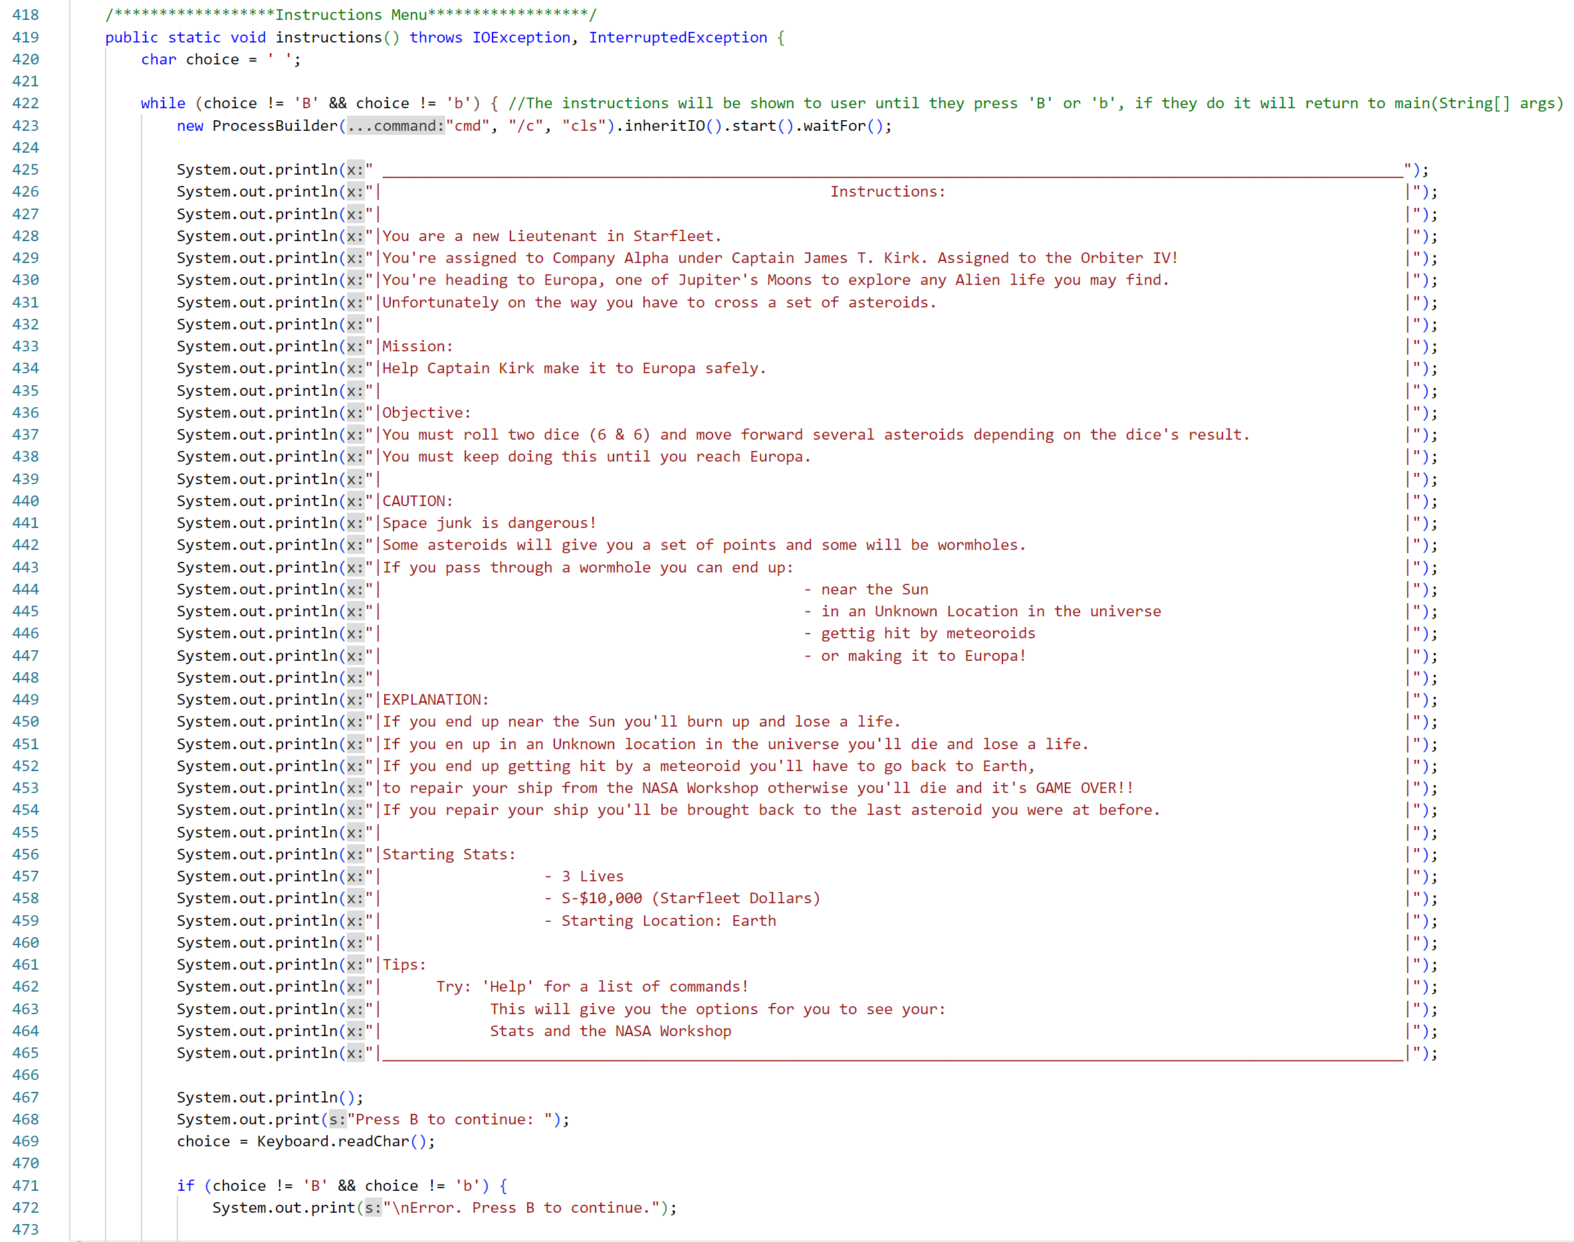

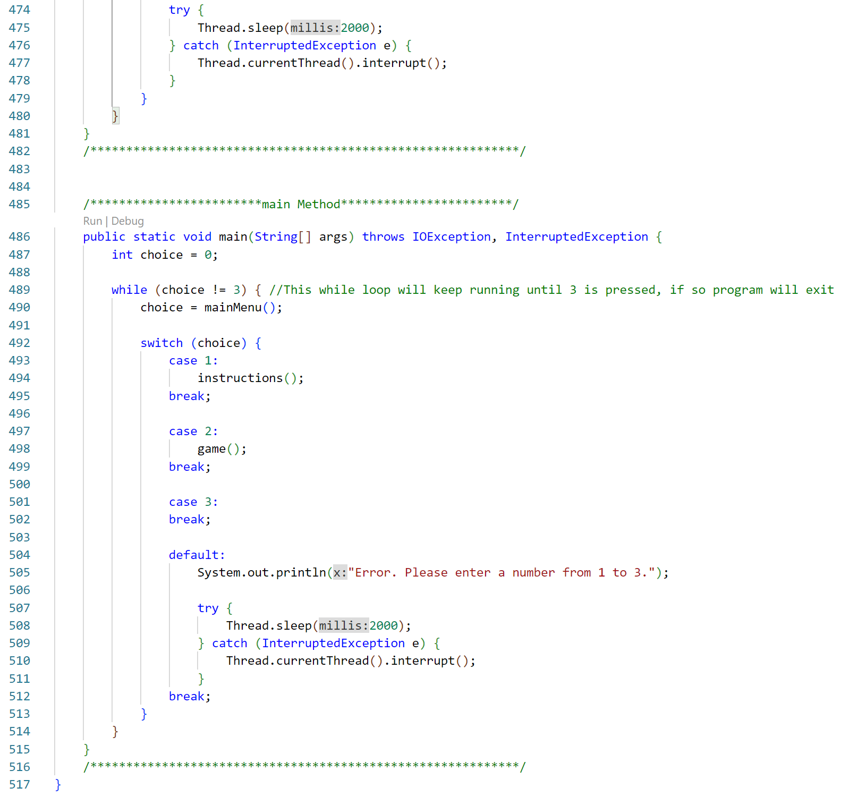

**Coursework Papers**

